Week 7-8 Documentation
Project: Smart Home Energy Consumption Forecasting
Student: Swapnil Pal
Duration: Week 7-8
- Objective

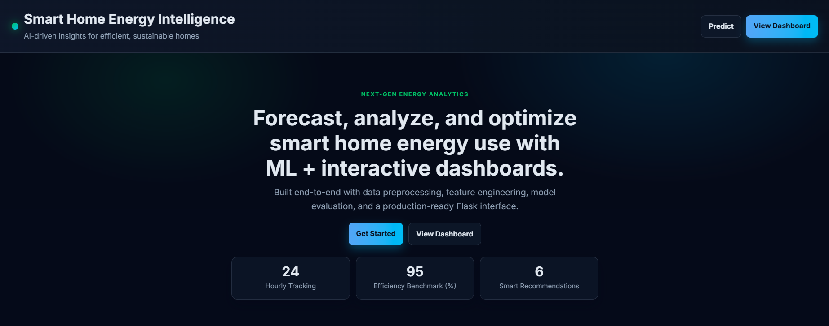
- Build a complete, user-facing web application for energy prediction.
- Integrate trained ML model (best_energy_model.pkl) with Flask backend.
- Improve UI/UX to make dashboard more premium, readable, and interactive.
- Validate prediction flow and data visualization APIs end-to-end.
2) Work Completed
Week 7: Backend Integration + Core Features
- Set up Flask app with modular routes for:
- Home page (/)
- Prediction API (/api/predict)
- Usage APIs (/api/usage/hourly, /api/usage/daily, /api/usage/weekly, /api/usage/monthly)
- Device usage API (/api/usage/devices)
- Health API (/api/health)
- Loaded trained model from best_energy_model.pkl.
- Implemented feature vector generation from form input:
- Numeric validation and range checks.
- One-hot handling for appliance type and season.
- Added robust model loading with fallback logic (pickle, legacy encoding, joblib).
- Implemented prediction caching (lru_cache) for faster repeated predictions.
- Added logging, request timing, and exception handling.
Week 8: Frontend Redesign + Interactivity

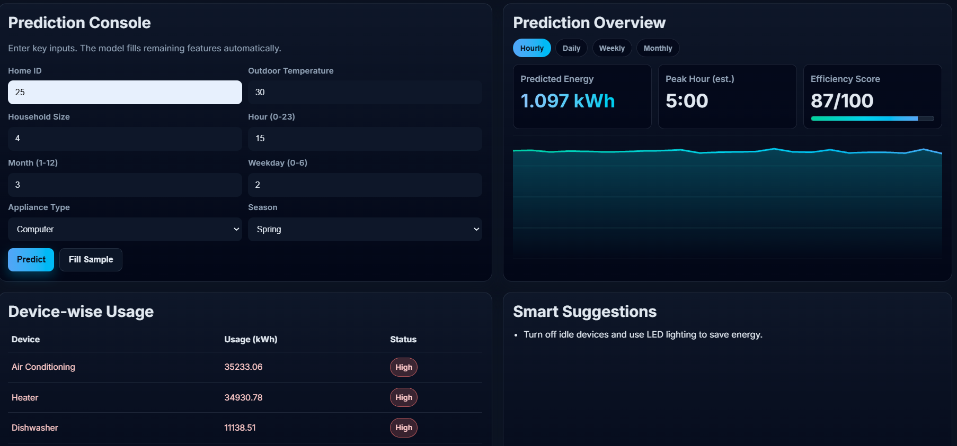

- Redesigned website with modern dark gradient theme and larger typography.
- Increased font sizes across all elements:
- Headings, labels, form fields, table data, KPIs, buttons, suggestions.
- Added rich dashboard interactions:
- Animated counters in hero section.
- Scroll reveal effects.
- Enhanced chart style (gradient line + area fill).
- KPI highlight effects and score progress bar.
- Device status highlighting (High vs Normal).
- Updated UX flow for prediction:
- Loading state (Predicting...)
- Better error display
- Dynamic KPI refresh after each prediction.
- Removed non-required content sections as requested:
- “Why This Project?” section removed.
- Footer tagline removed.

3) Technical Summary
- Backend: Python, Flask, NumPy, Pandas
- Model: best_energy_model.pkl (used in live inference via MODEL.predict)
- Frontend: HTML, CSS, JavaScript (vanilla)
- Data Handling: CSV preprocessing and aggregation for analytics APIs

4) Testing & Validation
- Verified model file is loaded at startup without runtime failure.
- Tested form validation for missing/invalid/out-of-range values.
- Verified API responses for prediction and usage endpoints.
- Checked dashboard updates for prediction results and suggestions.
- Confirmed no linter issues in edited frontend files.

5) Challenges Faced
- Path/config issues while running app in PowerShell due to incorrect working directory.
- Python launcher (py) misconfiguration on system.
- Ensuring UI enhancements did not break existing backend bindings.
- Aligning feature names with model training schema and fallback mappings.

6) Solutions Implemented
- Used explicit absolute path execution for Python where needed.
- Kept model inference flow unchanged while improving frontend only.
- Added defensive JavaScript checks for optional UI elements.
- Added robust backend error handling for API and page rendering.

7) Outcome
- Delivered a functional and visually improved intelligent energy forecasting web app.
- Prediction pipeline works with uploaded trained model.
- Dashboard is more interactive, readable, and presentation-ready.
- System now better suited for project demo, review, and final submission.

